Order Of Service

Singing: Psalm 23—CW page 72

Reading: Psalm 106:1-5

Opening Hymn: TLH 29

Reading: Acts 22:22-30

Request Hymn: CW Supplement 749

Reading: Matthew 10:1-4

Sermon Hymn: TLH 625

Sermon Text: Mark 9:30-37

A Little Child

Prayer

The Apostles’ Creed, TLH page 12

Holy Communion

The Lord's Prayer

The Blessing

Closing Hymn: TLH 48

* * * * * * * * * * *

Bible Study: Lambs: Pied-Bill Grebe
Sheep: Proverbs 20:1-5
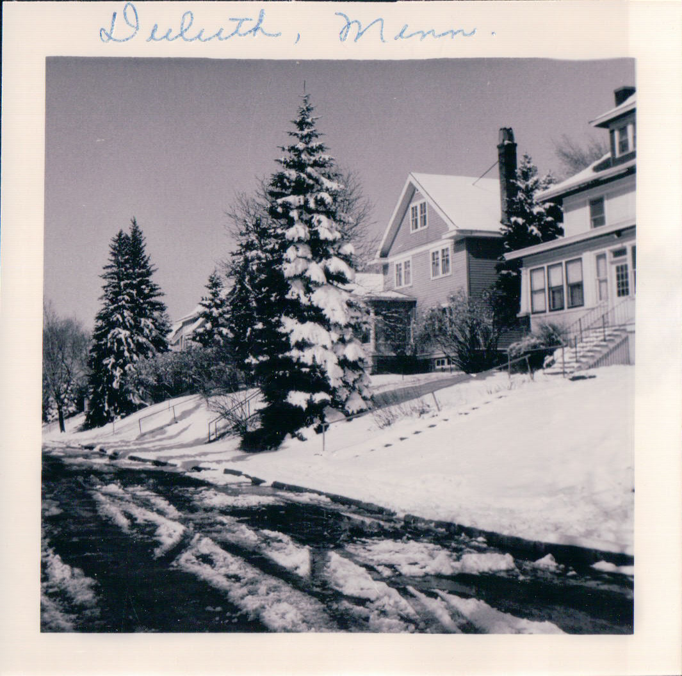

Our First Home—Duluth, MN

Water
Of
Life

8 September 2019

W A T E R O F L I F E

Independent Christian Church—Conservative Lutheran Doctrine

Worship Service: 9:30 a.m. Bible Study: 10:45 a.m.

Larry Cooper, Pastor E-Mail address:
111 N. Ridge Road lcooper@wateroflife.cc
Coon Valley, WI 54623 Web Site:
www.wateroflife.cc

* * * * * * * * * * * * * * * * * * * * * * * * * * *

Sermon Text: Mark 9:30-37

A Little Child

* * * * * * * * * * * * * * * * * * * * * * * * * * *

Mark 9:30 And they departed thence, and passed through Galilee; and he would not that any man should know it.
:31 For he taught his disciples, and said unto them, The Son of man is delivered into the hands of men, and they shall kill him; and after that he is killed, he shall rise the third day.
:32 But they understood not that saying, and were afraid to ask him.
:33 And he came to Capernaum: and being in the house he asked them, What was it that ye disputed among yourselves by the way?
:34 But they held their peace: for by the way they had disputed among themselves, who should be the greatest.
:35 And he sat down, and called the twelve, and saith unto them, If any man desire to be first, the same shall be last of all, and servant of all.
:36 And he took a child, and set him in the midst of them: and when he had taken him in his arms, he said unto them,
:37 Whosoever shall receive one of such children in my name, receiveth me: and whosoever shall receive me, receiveth not me, but him that sent me.

* * * * * * * * * *

